How to build up model
Step 1:
Make a R programing version of Land Application Unit (Generic Soil Column Module), the parameters can be adapted from the EPA biosolids draft.
Step 2:
Based on different animals’ diet compositions (cattle, swine, etc.), conduct literature review about bioaccumulation factors for different plants (corn, grass, legume, soybean hull, almond hull, or cottonseed).
Step 3:
Refine the pharmacokinetic for beef cattle and lactating dairy cows (Chou et al., 2023).
Step 4:
Calculate estimated daily intake. (including cow milk)
Step 5:
Consider impacts on breast milk?
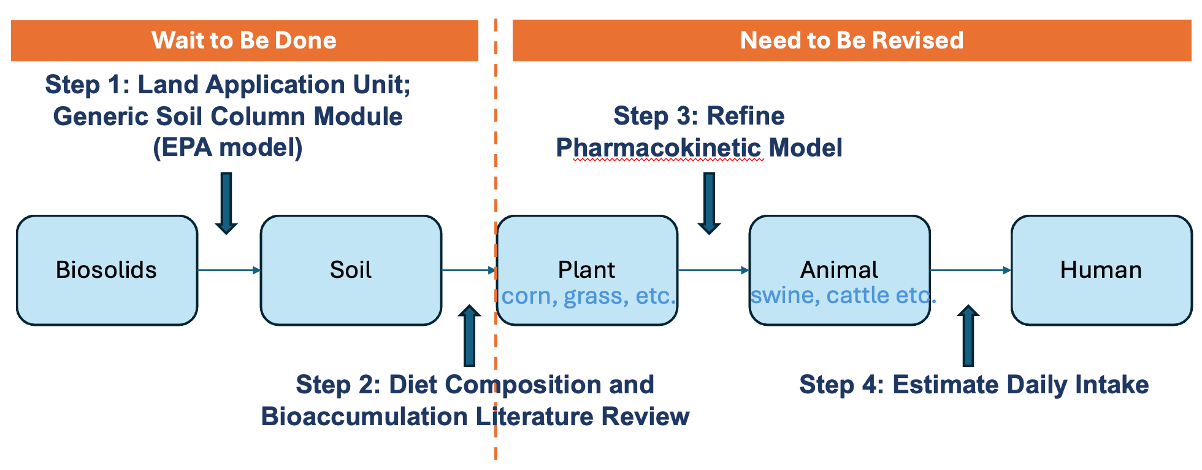
How to use this model (Aim)
- Based reference human exposure dose, give a safe level soil / biosolids concentration (Backward).
- Set up different soil / biosolids exposure scenarios, discuss the human estimated daily intake.
- Fix some conditions (reference dose, cost, etc.) to calculate a better diet composition.
How to visualize
- After select PFAS, the chemical related parameters will be displayed. The biosolids / soil concentration can be assigned to the model.
- After select animal type, diet composition, matter intake, soil intake, water intake will be provided. The parameters can also be revised manually.
- The bioaccumulation factor for different plants and their parts will be provided, which can also be revised manually.
- After choosing age group, the body weight adjusted consumption rate will be provided, which can be revised manually.
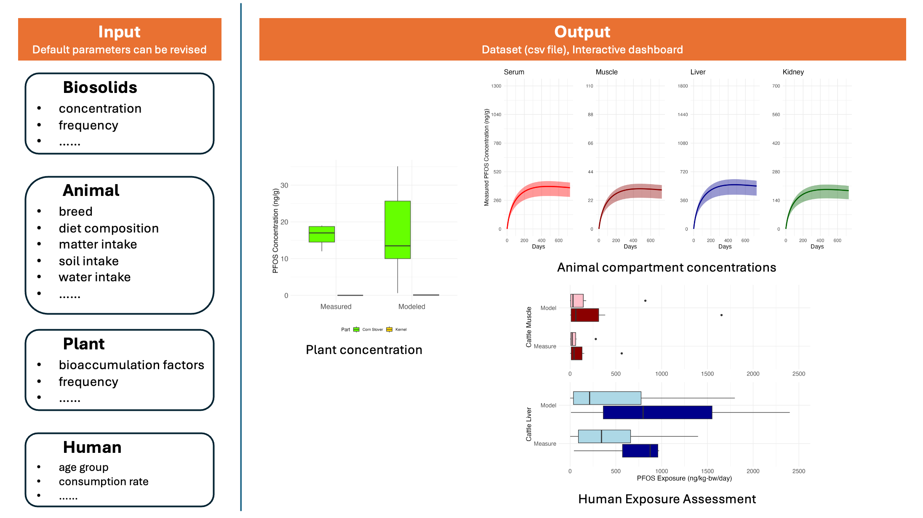

Maybe create another dashboard to show impact on breastmilk

